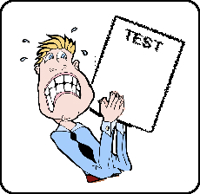

What to Do About Test Anxiety

There is a lot of anxiety when it comes to taking exams. The best way to deal with anxiety is to study extremely hard for exams. The anxiety never goes away completely, but being prepared will help you feel less stress.

Exams go hand in hand for most people. The desire to do well when you are evaluated creates a level of anxiety that is natural and expected. The symptoms of stress may include butterflies in the stomach, difficulty sleeping, irritability, nausea, loss of appetite, diarrhea, and headaches.

Here are some suggestions for managing anxiety when facing an exam.

- Prepare effectively. We tend to worry about things we do know about or are ill-prepared to meet.
- Remember that information and preparation translate into empowerment.
- Be careful not to give an exam more power than it is due. Exams are meant to measure a very limited amount of who you are as a person. They have no power to define your value or worth as an individual. They have no power to absolutely predict your future success.
- The outcome of an exam can be compromised by your physical and emotional state on the day you take the exam.
- Let the exam be a tool that measures your growth and provides feedback on how to improve, but do not let exams define you as a person.
- You are much bigger and more wonderful than the grade on an exam may suggest.
- Go into every exam assuming that at least one question will give you trouble.
- Do not let one or two questions derail your confidence and lead you into negative self-talk.
- It is entirely possible to pass most exams with a good grade even if you cannot answer one of the questions.
- Realize that you have power over your anxiety.
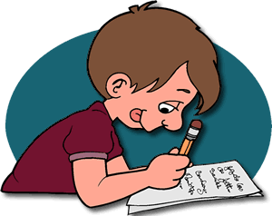
- On the day of the exam, arrive in class early.
- Sit in the seat and focus on the task ahead.
- Use the stress reduction techniques that you have learned.
- Visualize your success and then get to it.

Be at peace!

